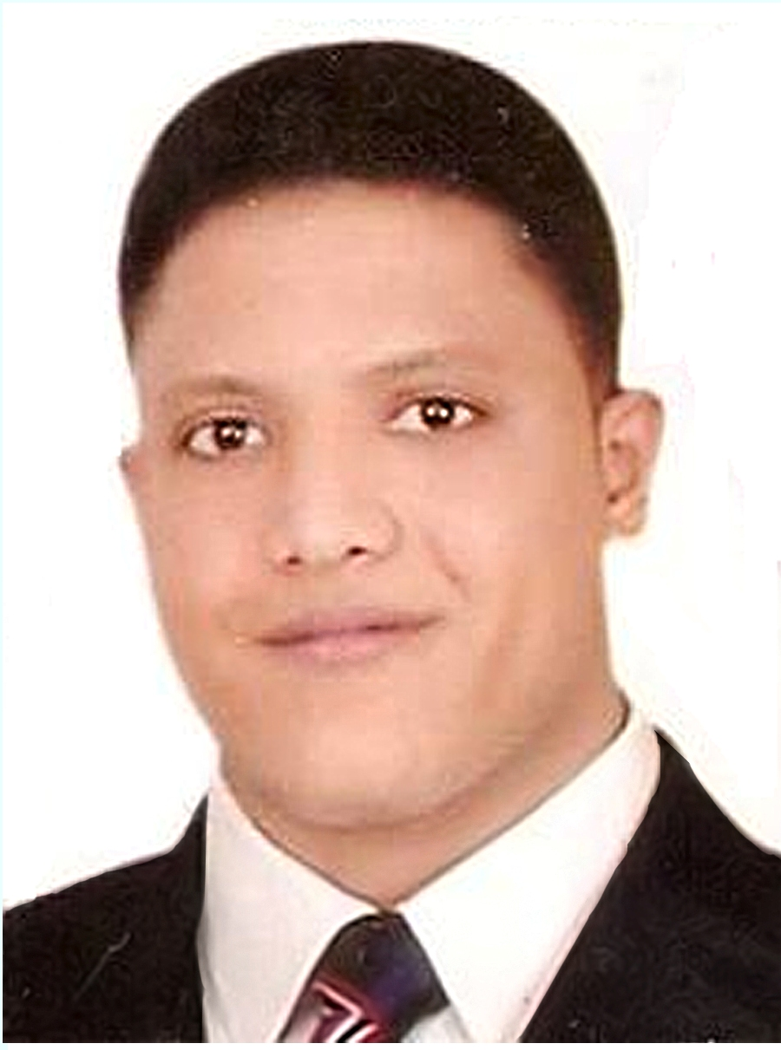
( C.V. )

- Personal Details :

Name : Abdel Tawab Metwally Ibrahim Zedan. -
Nationality : Egyptian.-
- Place And Date of Birth : Cairo , ( 14 / 11 / 1979 ).
- Sex : Male.
- Home Address : Zagazig City - Sharkia Governorate.
- Military Service : Exemption.
- Family Status : Married.
2) 01223509060 (+ Home Tel. :-
- Mobile. : (+ 2) 01223509060
- E-mail. : ( abdo10@mail.ru ) / ( mto252000@yahoo.com ).
682391 , Egypt. Passport Number :-

- Particulars Of Education And Qualifications :

 | Qualifications | Place | Date | Grade
1 | B.Sc. in Agriculture Science (Agricultural Engineering ). | Agricultural Engineering Department, Faculty of Agriculture ,  Zagazig University, Egypt. | June, 2000 | Excellent With The Honour Degree
2 | Diploma of Specialized Post-Graduate Studies in ( Land and Water Resources Management) "Irrigated Agriculture" | The International Center For Advanced Mediterranean Agronomic Studies. ( The Mediterranean Agronomic Institute of Bari ) / Italy. | July, 2003 | Excellent
3 | M.Sc. in Agricultural Engineering ( Land and Water Resources Management ) "Irrigated Agriculture" | The International Center For Advanced Mediterranean Agronomic Studies. ( The Mediterranean Agronomic Institute of Bari ) / Italy. | October,2005 | Excellent
4 | Ph.D. in Agricultural Engineering. | Moscow State University of Environmental Engineering,, Moscow, Russia. | March, 2012 | Excellent

- Details Of Present Employment :

[
- Name Of Employment : Lecturer.
- Work Address : Agricultural Engineering Department, Faculty of Agriculture,
Zagazig University, Egypt.

- Details Of Past Employment :

- Name Of Employment : Agricultural Specialist.
- Work Address : Atomic Energy Authority, Nuclear Research Center, Agricultural
Department for Soils and Water Research. Div. of Radioisotope Application,
Egypt.

- Experiences :

[
- Soil Moisture and Fertilizers (Salts) Distribution under Modern Irrigation Systems
by using the neutron scattering meter ( neutron probe and TDR meter).
- Irrigation system of vegetables crops under Egyptian and Russian conditions.
- The method of building monolithic lysimeters.
- Design , Management , Maintenance, and Evaluation of various mechanized
modern irrigation systems.( Drip, Sprinkler , Sub-Surface and another System)
- Water Management and Water Analysis.
- The Samples Analysis by using Atomicabsorption and Flamephtometer.
- Contribution in wide laboratories and field experiments.
- Co-designer of irrigation systems.
- Geographic Information System ( GIS ) Applications.

- Particulars Of Languages And Skills:

 | Languages | Place | Grade
1 | English | English Center For Specific Purposes , Zagazig University, Egypt. | Excellent
2 | Italian | The International Center For Advanced Mediterranean Agronomic Studies. ( The Mediterranean Agronomic Institute of Bari, Italy. | Excellent
3 | Russian | Moscow State University of Environmental Engineering,, Moscow, Russia and Russian center for science & culture in Cairo, Egypt. | Excellent
4 | Computer | Integrated Training Courses for University Graduates of Computer Skills  ( Computer Introduction / Windows 98 , 2000 , XP , Me , Win Word / Excel/ Access / Power Point / Internet / SPSSWIN ) Zagazig University, Egypt . | Excellent
5 | ICDL  (International Computer Driving License ) | Unesco | Excellent

- Conferences and seminars:

- The International Scientific Science Conference "The Role of Land Reclamation in providing food and environmental safety of Russia" Moscow State University of Environmental Engineering (MSUEE), Moscow, Russia, April, 2009.
- The International Scientific Science Conference "Problems of land reclamation and reproduction of soil fertility, Kuban State Agrarian University (KubSAU), Krasnodar, Russia, October, 2009.
- The seminar “New technologies in irrigation supplying food and ecology security” the seminar was held within the framework of the International Exhibition of the Agricultural Technique “Agrosaloon-2009” (KROKOS AXPO) in International center, Moscow, Russia, October, 2009.
- The 3rd All-Russian Scientific and Practical Conference of Young Scientists "Scientific provision of agro-industrial complex", Kuban State Agrarian University (KubSAU), Krasnodar, Russia, November 2009.
- The First International Conference on Economists and Management of Water in Arab World and Africa (EMWAWA) with the co-operation between Assiut Univ. & Moscow State Univ. of Environmental Engineering, Assiut University, Assiut University. Assiut, Egypt, 18-19 November 2009.
- The Second International Conference on Transboundary Water Resources Management, with the co-operation between Assiut Univ. & Moscow State Univ. of Environmental Engineering, Moscow State Univ. of Environmental Engineering, Moscow, Russia, 3-4 June, 2010.
- The 3-rd International Conference ( 7-th All-Russian Scientific and Practical Conference of Young Scientists) “Innovative new technologies and environmental safety in the irrigation” , International center for Conferences ,(VVC) Moscow, Russia 2010.
- The seminar “New technologies in irrigation supplying food and ecology security” the seminar was held within the framework of the International Exhibition of the Agricultural Technique “Agrosaloon-2010” (KROKOS AXPO) in International center, Moscow, Russia, October, 2010.
- The Youth Science and Environmental Forum, "Analysis of the causes and effects of drought and fires of 2010: the priority problems and their solutions." 9 -10 December 2010 at Moscow State University of Environmental Engineering (MGUP). Moscow, Russia 2010.
- The 4-rd International Conference ( 8-th All-Russian Scientific and Practical Conference of Young Scientists) “Innovative new technologies and environmental safety in the irrigation” institute "Raduga", Kalomna, Russia 2011.
- The 19 ^{th}. Annual Conference of the Misr Society of Agricultural Engineering “Prospects of Modern Technology in Agricultural Engineering and Management of Environmental Problems” Agricultural Engineering Department, Faculty of Agriculture, Al Mansoura University, Egypt, 14-15 November 2012.
- The international scientifically-practical conference Problems of complex arrangement technogene systems, 16-18 April 2013 Moscow State University of Environmental Engineering (MSUE). Moscow- Russia
- International Scientific and Practical Conference THE INVENTORY OF LAND RESOURCES: STATUS, PROBLEMS AND PROSPECTS (devoted to the 100th anniversary of the first graduate Russian meliorator) 29-30 May 2013 Novocherkassk State Reclamation Academy Novocherkassk – Russia
- VI-th International (10th All-Russian) Conference of Young Scientists and Specialists "Innovative technology and environmental safety in the reclamation" 26-28 June 2013 Institute "Radoga" Moscow region, Kalomna district
- The international scientific conference " devoted to the 150th anniversary of academician V.R." 3 - 5 December, 2013 Moscow, Russia Ministry of Agriculture of the Russian Federation Russian State Agrarian University - Moscow Agricultural Academy named after K.A. Timiryazev.

- Publications:

- Use of neutron scattering meter to detect soil moisture distribution under trickle irrigation system in sandy soil of Inshas, Egypt.
- Effect of different levels of water consumptive use of squash under drip irrigation system on salt distribution, yield and water use efficiency.
- Irrigation regime squash under Egyptians conditions. (Text: Abdel Tawab M. I.) Proceedings of the International scientific Science Conference. Part II. (Russia, Moscow, April 15-17, 2009.) MSUEE (ФГОУ ВПО МГУП), 2009 p. 395-399.
- Irrigation regime beans under Egyptians conditions, (Text: Abdel Tawab M. I., Ahmed S. F.) Proceedings of the 2 nd International scientific Science Conference. (Russia, Krasnodar, October 14-16, 2009.) KubSAU (ФГОУ ВПО КубГАУ), 2009, p. 17-22.
- Effect of Water Regimes on Squash Yield, Water Use Efficiency and Salt Distribution.( Text: Pchelkin V.V., Abdel Tawab M. I.) Proceedings of The First International Conference on Economists and Management of Water in Arab World and Africa (EMWAWA) with the co-operation between Assiut Univ. & Moscow State Univ. of Environmental Engineering, Assiut University. Assiut, Egypt, 18-19 November 2009 p. 285-299.
- Vegtable marrow water consumption under drip irrigation in Egypt. (Text: Pchelkin V.V., Abdel Tawab M. I.), Reclamation and Water Management, Scientific and practical journal, (R&WM) ISSN 0235-2524. № 6, 2009, P.49-51.
- Bean water requirements under drip irrigation. (Text: Pchelkin V.V., Abdel Tawab M. I.), Reclamation and Water Management, Scientific and practical journal,(R&WM) ISSN 0235-2524. № 3, 2010, P. 27-28.
- Analysis of changes in the air humidity of Egypt. (Text: Pchelkin V.V., Abdel Tawab M. I. Sharshef E. S.) Proceedings of the Second International Conference on Transboundary Water Resources Management, with the co-operation between Assiut Univ. & Moscow State Univ. of Environmental Engineering, (MSUEE) Moscow State Univ. of Environmental Engineering, Moscow, Russia, 3-4 June, 2010. p. 122-126.
- Analysis of changes in the air temperature of Egypt. (Text: Abdel Tawab M. I.) Proceedings of the Ministry of Agriculture and in the collection of institute "Raduga" in the 3-rd International Conference (7-th All-Russian Scientific and Practical Conference of Young Scientists) “Innovative new technologies and environmental safety in the irrigation” Moscow, Russia 2010.
- Studying of moisture regime sod-podzolic soil for growing beet. (Text: Pchelkin V.V., Abdel Tawab M. I.) In Scientific and practical Journal of Environmental Engineering, 2011, № 1.
- Studying of moisture soil regime for growing squash under Egyptians conditions. (Text: Pchelkin V.V., Abdel Tawab M. I.) Proceedings of the Ministry of Agriculture and in the collection of institute "Raduga" in the 4-rd International Conference (8-th All-Russian Scientific and Practical Conference of Young Scientists) “Innovative new technologies and environmental safety in the irrigation” "Raduga", Kalomna, Russia 2011.
- Determined of Water Requirements For Vegetables Under Drip Irrigation System, (Text: Zedan A. M., Mattar M. A.) ,The 19 ^{th}. Annual Conference of the Misr Society of Agricultural Engineering “Prospects of Modern Technology in Agricultural Engineering and Management of Environmental Problems” Agricultural Engineering Department, Faculty of Agriculture, Al Mansoura University, Egypt, 14-15 November 2012. p. 607-620.
- Effect of use rice straw and soil water conservation on growth and productivity in mango orchard, (Text: Zedan A. M., Hashish A. I.) Proceedings of The international scientifically-practical conference Problems of complex arrangement technogene systems, 16-18 April 2013 Moscow State University of Environmental Engineering (MSUE). Moscow- Russia, ISBN 978-5-89231-450-3.part 1, 2013, P. 3-20.
- Effect of magnetized water with different magnetic fields on growth performance of fish, (Text: Zedan A. M., Elsaeyed A. S.) Proceedings of The international scientifically-practical conference Problems of complex arrangement technogene systems, 16-18 April 2013 Moscow State University of Environmental Engineering (MSUE). Moscow- Russia, ISBN 978-5-89231-452-7.part 6, 2013, P. 4-14.
- Effect of Water Toxicity and Water Temperature on Some Physiological Parameters of Nile tilapia (Oreochromis niloticus) (Text: Zedan A. M., Wafeek M. A.), Proceedings of The International Scientific and Practical Conference THE INVENTORY OF LAND RESOURCES: STATUS, PROBLEMS AND PROSPECTS (devoted to the 100th anniversary of the first graduate Russian meliorator) 29-30 May 2013 Novocherkassk State Reclamation Academy Novocherkassk – Russia, ISBN 978-5-8431-0281-4.part 2, 2013, P. 69-83.
- Optimum operating conditions for different sprinklers, (Text: Zedan A. M., El-Sayed A. S., Khedr A. F.), Proceedings of The VI-th International (10th All-Russian) Conference of Young Scientists and Specialists "Innovative technology and environmental safety in the reclamation" 26-28 June 2013 Institute "Radoga" Moscow region, Kalomna district,YDK 631.347,P. 5-16.
- Effectiveness of innovative reclamation technologies in arid climate under Tajikistan conditions, (Text: Zedan A. M., Sheraliev A. N.), Proceedings of The VI-th International (10th All-Russian) Conference of Young Scientists and Specialists "Innovative technology and environmental safety in the reclamation" 26-28 June 2013 Institute "Radoga" Moscow region, Kalomna district,YDK 502/504:338:556.18.,P. 155-157.
- Water consumption of red beet at the automorphic sod-podzolic soils of Moscow Region , Reclamation and Water Management, Scientific and practical journal, (R&WM) ISSN 0235-2524. № 5, 2013, P.13-15.
- Relationship between evaporation from the water surface and water consumption of red beet and vetch-oat mixture under Russian conditions. (Text: Abdeltawab M. I., Pchelkin V. V., Shilnikov D. V.), Proceedings of The international scientific conference " December, 2013 Moscow The international scientific conference " devoted to the 150th anniversary of academician V.R." 3 - 5 December, 2013 Moscow, Russia Ministry of Agriculture of the Russian Federation Russian State Agrarian University - Moscow Agricultural Academy named after K.A. Timiryazev.

- Awards :

  - Certificate of merit and thanks from Kuban State Agrarian University for active participation and interesting research paper on a topical theme in The 2-nd International Scientific Science Conference "Problems of land reclamation and reproduction of soil fertility”, Kuban State Agrarian University (KubSAU), Krasnodar, Russia, October, 2009.
  - Similar were sent certificate of thanks and awarded to Vice-president Moscow State Univ. of Environmental Engineering in Moscow (prof : V. Krasnoshekov) and director of the Culture Bureau of the Embassy of the Arab Republic of Egypt in Moscow (prof : Magdy Elias Fares), 2009.
  - Certificate of merit for active participation in scientific research in priority areas of agro-industrial complex in the 3-rd All-Russian Scientific and Practical Conference of Young Scientists (scientific support for agro-industrial complex). Krasnodar, Russia, November 2009.

  - Certificate of merit for the best research paper in Conference in the 3-rd International Conference ( 7-th All-Russian Scientific and Practical Conference of Young Scientists) “Innovative new technologies and environmental safety in the irrigation” , Moscow, Russia, October, 2010.

  - Certificate of merit for the II place in the Youth Science and Environmental Forum, "Analysis of the causes and effects of drought and fires of 2010: the priority problems and their solutions." in the section on "Ecological optimization of forest and land management in Russia." Moscow, Russia 2010.

  - Certificate of patent for an invention ” The method of building monolithic lysimeters”, Federal Service of Intellectual Property, Patents and Trademarks, 2011, Moscow, Russia.

  - Certificate of merit and thanks from The international scientifically-practical conference Problems of complex arrangement technogene systems, 16-18 April 2013 Moscow State University Moscow- Russia.
  - Certificate of merit and thanks from International Scientific and Practical Conference THE INVENTORY OF LAND RESOURCES: STATUS, PROBLEMS AND PROSPECTS 29-30 May 2013 Novocherkassk – Russia.
  - Certificate of merit and thanks from VI-th International (10th All-Russian) Conference of Young Scientists and Specialists 26-28 June 2013 Institute "Radoga" Moscow region, Kalomna district.
  - Certificate for assisting a one day training course in Human development skills (Physiological impacts of abnormal situations and its treatment).faculty of agriculture, Zagazig University.
  - Certificate for attended specialized training workshop on “improving water productivity in irrigated agriculture with focus on mechanized raised-bed wheat planting” organized by the international center for agricultural research in dry areas (ICARDA) held at 24-28 may at cairo, Egypt .

  - شهادة تقدير من وزارة التعليم العالى وحدة ادارة المشروعات فى اختياز الانشطة التدريبية فى مشروع تنمية مهارات اعضاء هيئة التدريس ومعاونيهم لجامعة الزقازيق فى تقويم الطلاب فى ضوء الاتجاهات العالمية المعاصرة.
  - شهادة تقدير من محافظ الشرقية ومديرية التنظيم والادارة على اجتياز التدريب فى مجال الكمبيوتر واللغة الانجليزية والادارة العامة بنجاح.
  - شهادة تقدير من الجمعية الامريكية للهندسة الزراعية بامريكا للمشاركة الفعالة فى الجمعية.
  - شهادة تقدير من السفارة المصرية و المكتب الثقافى بموسكو بروسيا تقديرا خلال فترة تولى نائب رئيس عام اتحاد الطلاب المبعوثين بروسيا الاتحادية للعام 2010-2011.
  - شهادة تقدير من السفارة المصرية و المكتب الثقافى بموسكو بروسيا تقديرا على الحصول على براءة اختراع فى مجال الزراعة والرى 2012.
  - شهادة تقدير من السفارة المصرية والمكتب الثقافى بموسكو بروسيا تقديرا للحصول على درجة الدكتوراه فى الهندسة الزراعية من جامعة موسكو الحكومية للهندسة البيئية بموسكو –روسيا عام 2012.
  - شهادة تقدير من رئيس جامعة الزقازيق ونادى اعضاء هيئة التدريس تقديرا للحصول على درجة مدرس فى خلال عام 2012.
  - شهادة تقدير من الجمعية المصرية للهندسة الزراعية على المشاركة الفعالة فى الموتمر التاسع عشر للهندسة الزراعية بجامعة المنصورة 2012.
  - شهادة تقدير وشكر من نائب رئيس جامعة الزقازيق والادارة العامة للمشروعات على المشاركة الفعالة فى ورشة العمل تدوير المخلفات الزراعية وقش الارز 2012.
  - شهادة تقدير من المكتب الثقافى بموسكو بروسيا الاتحادية تقديرا للمشاركة الفعالة فى المؤتمرات العلمية الدولية المتخصصة فى مجال الهندسة الزراعية عام 2014 بجامعة موسكو الحكومية للهندسة البيئية بدولة روسيا الاتحادية.
  - شهادة حضور ورشة العمل تحت عنوان التعامل مع التغير من هيئة ال DAAD الهيئة الالمانية للتبادل العلمى – جامعة الزقازيق – ادارة المشروعات والتطوير عام 2014.
  - شهادة تقدير من اكادمية البحث العلمى للمشاركة فى معرض القاهرة الدولى الاول لابتكار 19-20 نوفمبر 2014 الذى اقيم فى الجامعة الامريكية.
  - شهادة تقدير من جامعة الزقازيق – مكتب الابتكار ونقل التكنولوجيا للدور الفعال والمشاركة المتميزة فى معرض القاهرة الدولى الاول لابتكار 19-20 نوفمبر 2014 الذى اقيم فى الجامعة الامريكية.
  - شهادة تقدير للمشاركة والعمل كمشرف تنفيذى فى دورات تنمية اعضاء هيئة التدريس وقيادات الجامعة بجامعة الزقازيق من 2012 حتى الان.
  - تصوير حلقة فى برنامج الحصاد المذاع يوم 24 نوفمبر2014 على قناة مصر الزراعية.
  - تصوير حلقة فى برنامج بنصبح عليك يوم 14 يناير 2015 المذاع على القناة الثانية الفضائية.
  - شهادة تقدير للمشاركة الفعالة فى مؤتمر اليوم العالمى للاراضى فى 15-16 ديسمبر 2014 بورقة بحثية بوستر بعنوان (طريقة بناء الليسيمترات المتجانسة ) بقسم الاراضى –كلية الزراعة – جامعة الزقازيق.
  - شهادة شكر وتقدير من نادى اعضاء هيئة التدريس بكلية الزراعة جامعة الزقازيق للمشاركة الفعالة اثناء فعاليات دورى كرة القدم الاول لاعضاء هيئة التدريس عام 2015 فى 22\2 الى 7\3\2015 .
  - شهادة شكر وتقدير من كلية الزراعة جامعة الزقازيق للمشاركة الفعالة فى دورة التنمية البشرية عام 2015 .
  - شهادة تقدير للمشاركة الفعالة فى معرض الابتكار الاول بجامعة عين شمس فى 27- 29 ابريل 2015 بمشروع بعنوان (بناء الليسيمترات المتجانسة ) بجامعة عين شمس.
32 - شهادة تقدير للمشاركة فى ورشة عمل بعنوان (تحسين انتاجية المياة فى الاراضى الزراعية ) فى 24- 28 مايو 2015 من المركز الدولى الزراعى (ايكاردا ) – مصر.
33 - جائزة وشهادة تقدير فى مسابقة افضل 15 ابتكار للجامعات والمعاهد البحثية المصرية لعام 2015 (الشباب هو الامل والابتكارات هى الحل ) من شبكة كونكت أرابز للإبتكارات العربية ConnectArabs 2015.
34 - جائزة كيشيدا للتفوق العلمى فى الهندسة الزراعية- مؤتمر الجمعية المصرية العشرون للهندسة الزراعية بعنوان (الهندسة الزراعية وتحديات الوطن) – قسم هندسة النظم الحيوية والزراعية – كلية الزراعة بمشتهر – جامعة بنها -مصر -12-12- 2015.

